**Merge Stage**

The Merge sage is a processing stage that can combine a master data set with one or more update datasets. This stage is one of three stages that join tables based on the values of key columns, along with Join and Lookup stages.

This stage is usually used when the master table needs to be updated from multiple reference tables with the same key. It can also give reject links per reference table.

**Key Points**

* The Merge stage can have any number of input links, single output links and the same number of reject output links as the update input links.
* A master record and an update record are merged only if both of them have the same values for the specified merged key. In another word, merge stage does not do range lookup.
* To minimise memory requirements, we can ensure that rows with the same key column values are located in the same partition and is processed in the same node by partitioning. However, the ‘auto’ option for partitioning usually works fine.
* As part of preprocessing, duplicate records need to be removed from the master. If there are more than one update data sets, it only updates the first record as below.

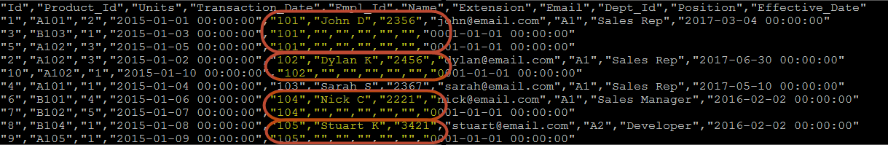

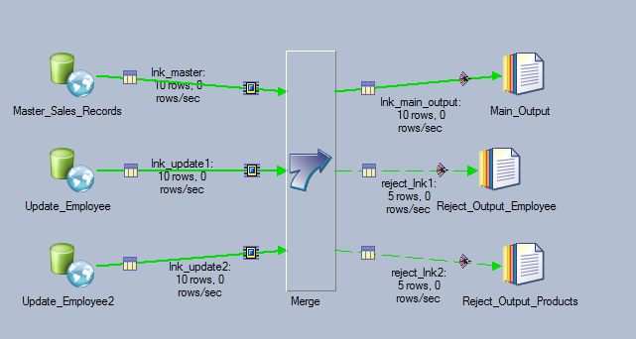

Merge stage has only 3 options, Unmatched Master Mode, Warn On Reject Updates and Warn On Unmatched Master.

All the tables have to have the same column names for the merge keys.

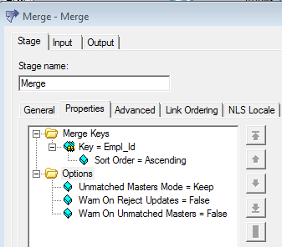

Configure input and output links. Map them to the right link order.

